

LAB EXPERIMENT RECORD
SET 13

Department | Artificial Intelligence and Data Science
Course Code / Course Name | DSA0601 / Data Handling and Visualization
Name / Register Number | ROHAN P T / 192424112
Date / Day | 08/10/2026

Aim
To analyze geographic data analysis using the requested visualizations and dashboard views.

Dataset
Geographic Data Analysis
City | Population | Avg_Temperature | Elevation | Map_X | Map_Y
City A | 500000 | 75 | 1000 | 0.2 | 0.4
City B | 700000 | 68 | 800 | 0.7 | 0.7
City C | 600000 | 80 | 1200 | 0.8 | 0.25

R Data Setup
Run this setup once before the R programs below. The dataset is defined inline so each record can be copied and run without a separate CSV file.
R data setup
dat <- data.frame(
City = c("City A", "City B", "City C"),
Population = c(500000, 700000, 600000),
Avg_Temperature = c(75, 68, 80),
Elevation = c(1000, 800, 1200),
Map_X = c(0.2, 0.7, 0.8),
Map_Y = c(0.4, 0.7, 0.25)
)

PROGRAM 1: City Map Chart
Create a labeled map chart to show the distribution of the cities.
R code
plot(dat$Map_X, dat$Map_Y, pch=21, bg="skyblue3", cex=1.6, xlab="Illustrative east-west position", ylab="Illustrative north-south position", main="Schematic City Locations")
text(dat$Map_X, dat$Map_Y, labels=dat$City, pos=3, cex=.8)

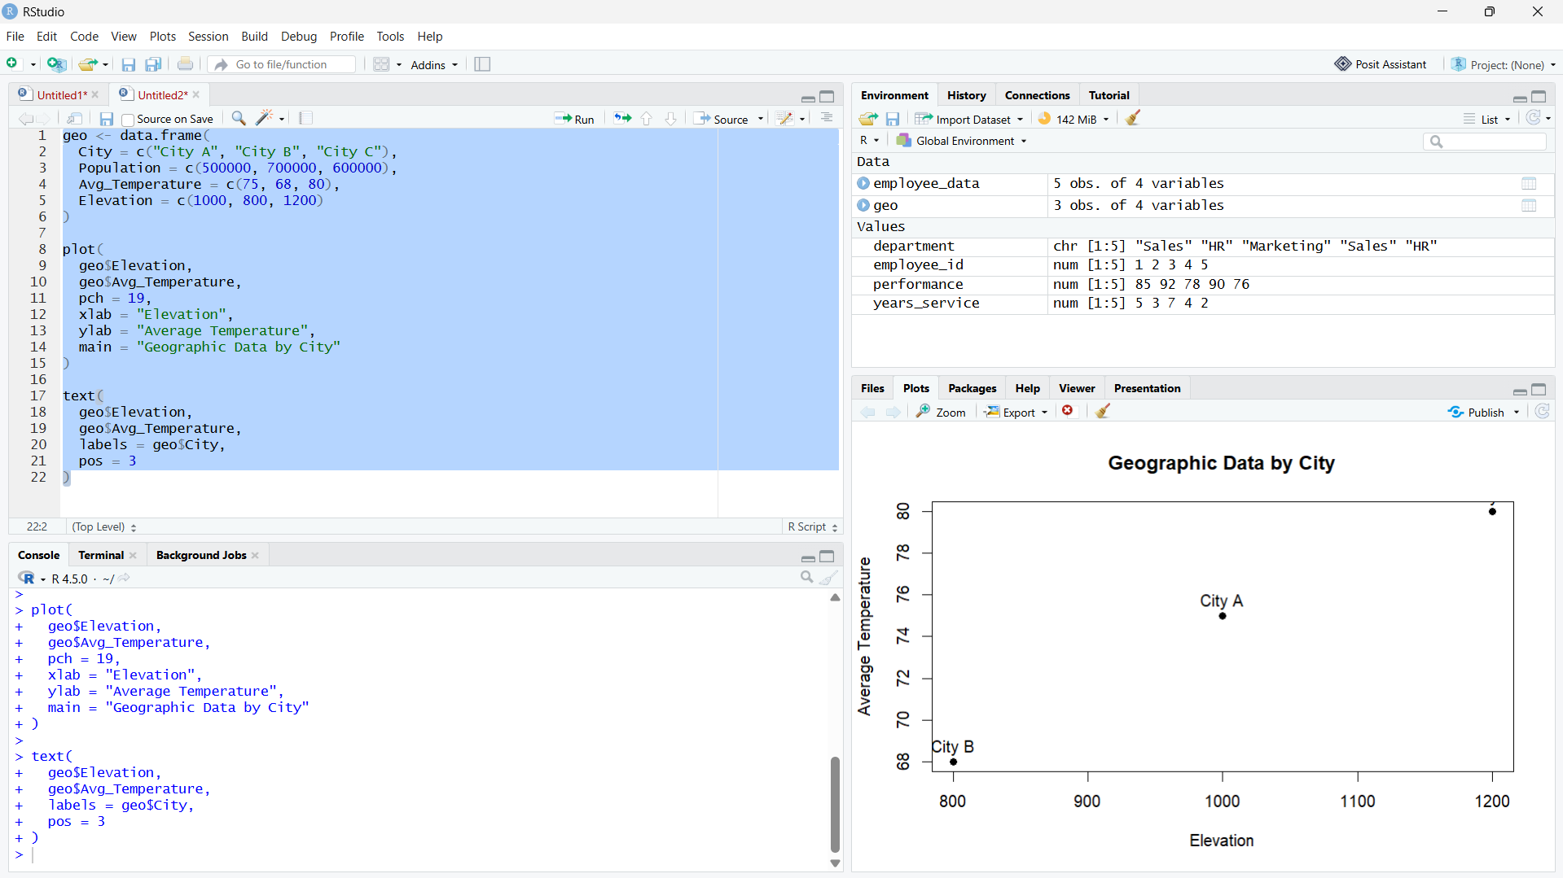

Output 1: City Map Chart

Observation: The map-style output shows three labeled city markers sized by population. Their positions are schematic because the city names are placeholders.

PROGRAM 2: Temperature and Population Scatter Plot
Create a scatter plot of average temperature versus population and describe the pattern.
R code
plot(dat$Avg_Temperature, dat$Population, pch=19, col="#276B9A", xlab="Average temperature (°F)", ylab="Population", main="Temperature vs Population")

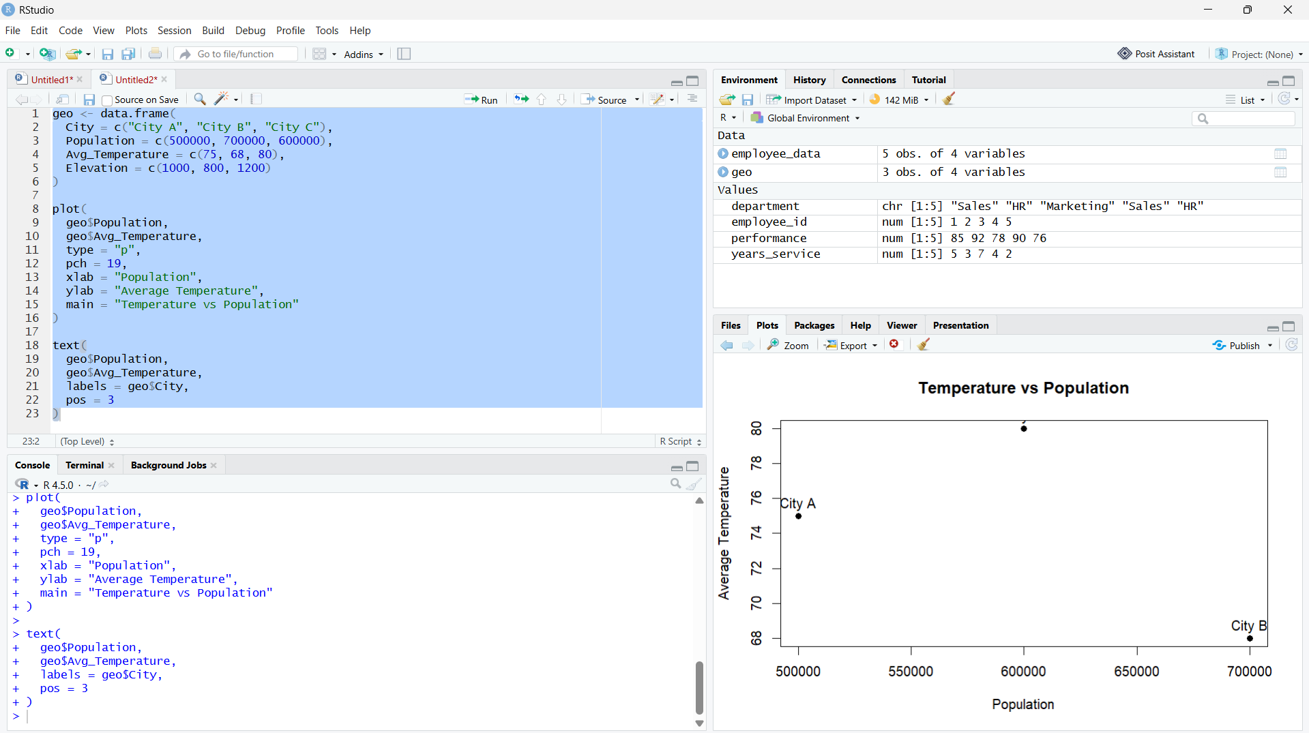

Output 2: Temperature and Population Scatter Plot

Observation: Among these three illustrative city records, City C is warmest and City B has the largest population; three points are insufficient for a reliable trend.

PROGRAM 3: Geographic Data Table
Display the geographic data for each city in a labeled table.
R code
print(dat)

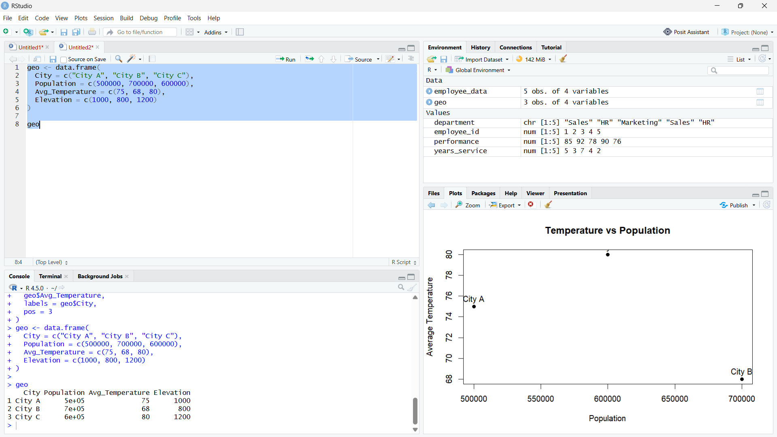

Output 3: Geographic Data Table
Observation: The table includes population, average temperature, and elevation for all three cities.

PROGRAM 4: Geographic Data Dashboard
Create a Tableau dashboard combining the map, scatter plot, and city data table.
Tableau build steps
Tableau dashboard build
1. Connect to the geographic data table.
2. Use Map_X and Map_Y for a schematic point map, or replace them with real geographic fields.
3. Create a scatter plot of Avg_Temperature and Population.
4. Add the city table and place all three sheets on a dashboard.

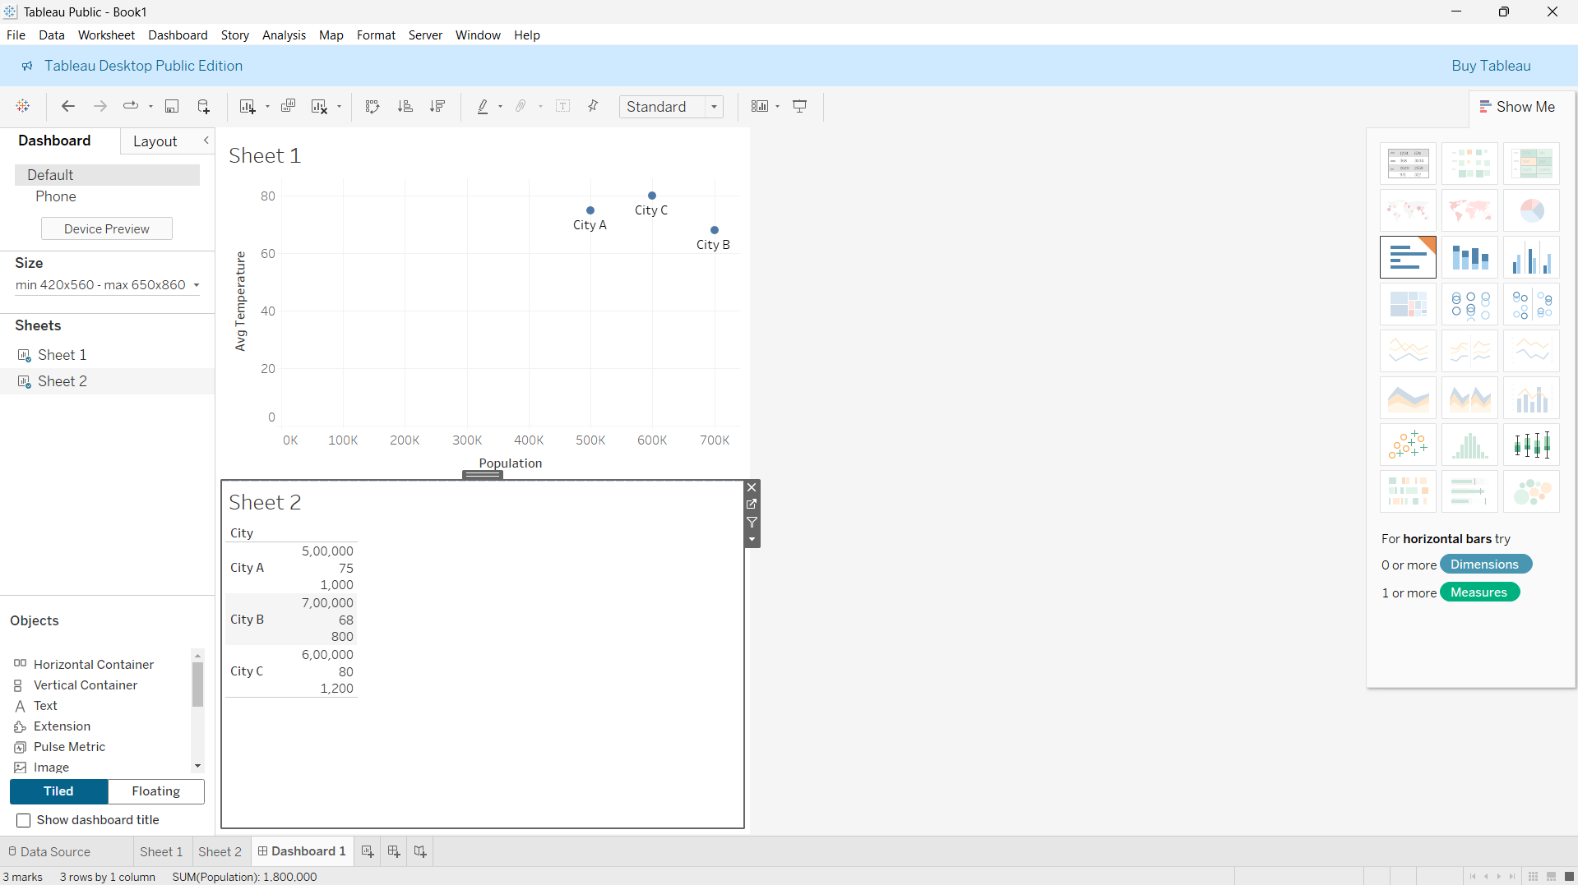
Output 4: Geographic Data Dashboard
Observation: The preview combines the schematic locations, temperature-population comparison, and city details.

Procedure
1. Review the dataset table and confirm any illustrative fields noted in the record.
2. Run the R setup block once, then run the requested program code.
3. Compare the output screenshot with the observation and replace illustrative values when actual data is available.
4. For Tableau tasks, connect to the displayed data and follow the dashboard build steps.

Result
The requested charts and dashboard views for Set 13 were prepared from the displayed dataset. Outputs include labels, short observations, and code or dashboard construction steps.

Key Functions Used
plot(), barplot(), hist(), boxplot(), table().

